Requirement Analysis
Customer Journey Map
Date | 12 July 2026
Team ID | SWTID-2026-4644
Project Name | Smart Lender
Phase | 2. Requirement Analysis

Scenario: Applying for a Loan Through Smart Lender
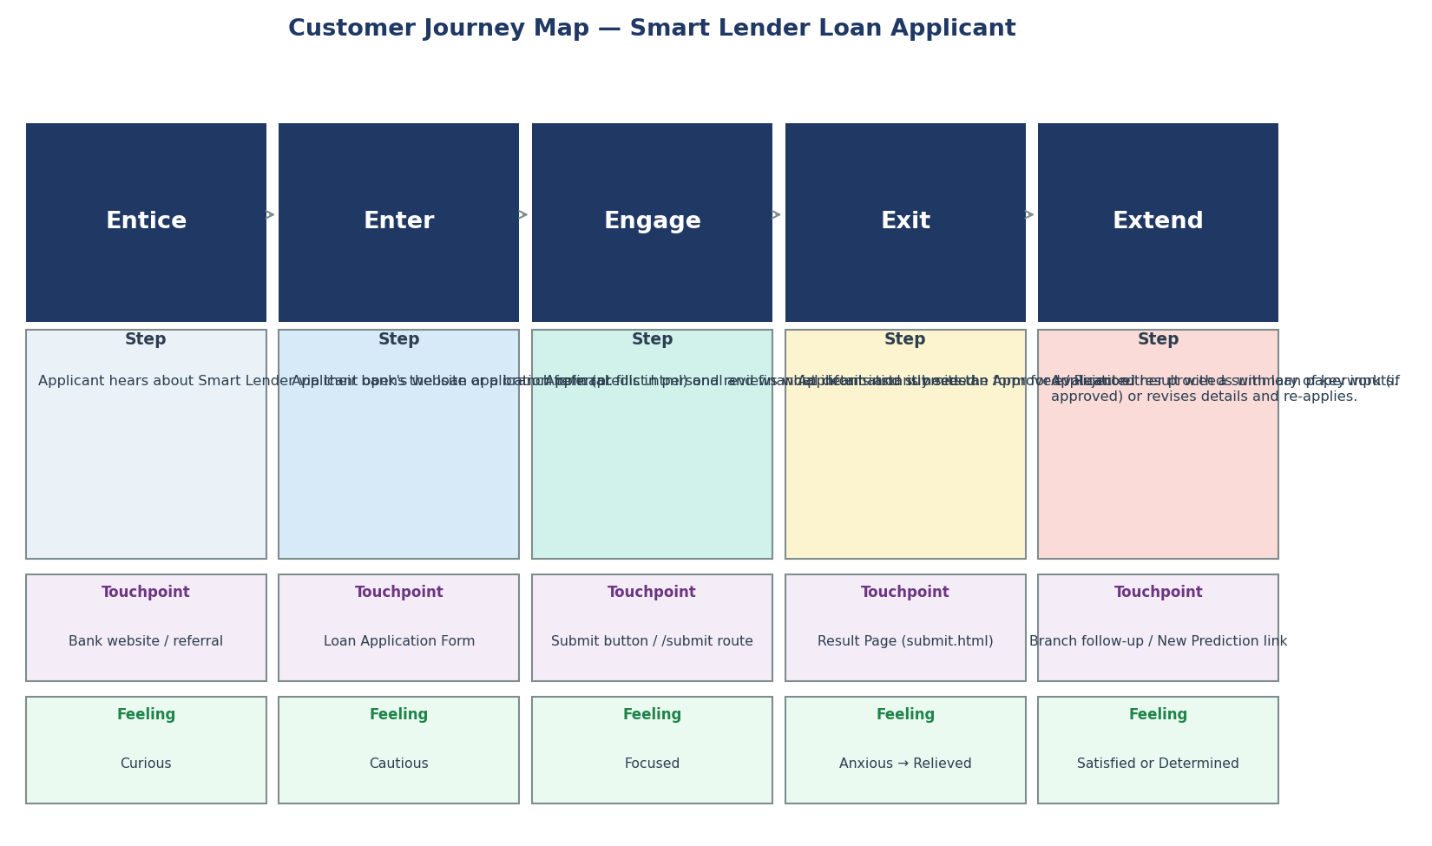
The map below traces a Loan Applicant's experience across five stages — Entice, Enter, Engage, Exit, and Extend — from first hearing about Smart Lender through to receiving (and acting on) their eligibility result. It was built directly from the application's actual routes and templates, so every touchpoint corresponds to a real page or route in the codebase.

Figure 1: Customer Journey Map — Smart Lender Loan Applicant.

Stage-by-Stage Detail
- Entice — the applicant hears about Smart Lender via their bank's website or a branch referral; emotional state: curious.
- Enter — the applicant opens the loan application form (predict.html) and reviews what information is needed; emotional state: cautious.
- Engage — the applicant fills in personal and financial details and submits the form for evaluation; emotional state: focused.
- Exit — the applicant instantly sees an Approved/Rejected result with a summary of key inputs; emotional state: anxious → relieved. This is the highest-stakes moment in the journey.
- Extend — the applicant either proceeds with loan paperwork (if approved) or revises details and re-applies; emotional state: satisfied or determined.

Key Takeaways
The applicant's anxiety peaks at the Exit stage while waiting to see the result — this is the moment the instant, same-request prediction (rather than a delayed manual review) delivers the most value. The Extend stage — what happens after approval or rejection — is currently outside the application's scope (no follow-up email, status tracking, or reapplication guidance beyond the 'New Prediction' link) and is logged as future scope in the Brainstorming & Ideation phase.

